# CS 255 Business Requirements Document

**DriversPass**

*Brian Fulton*

*5 June 2022*

## System Components and Design

### Purpose

* + - * DriverPass is a new start up company that will offer their clients hands on drivers training aimed at improving the pass rate for the DMV drivers test.
      * Company data must be accessible via internet and downloadable
  + Client uses Microsoft products, data must be compatible

**System Background**

* + - * DriverPass wants to offer it’s clients drivers training and knowledge needed to confidently pass the DMV drivers license test
        + By providing in person behind the wheel training and online resources with practice tests; DriversPass will greatly improve the DMV license test pass rate of their clients
        + DriversPass is a mobile company operating with 10 vehicles that can pick-up and drop off it’s clients at user selected locations to provide their services
        + The online foot print of DriversPass handles the administrative functions of the business

Online booking or by calling DriverPass secretary

Updated and most current DMV data

Online practice tests

DriverPass owner access

User activity tracking

Scheduling

Data stored remotely for download availability

Employee management

Make packages unavailable when necessary

### Objectives and Goals

*What should this system be able to do when it is completed? What measurable tasks need to be included in the system design to achieve this?*

* + - * DriverPass will operate their cloud hosted site to sell drivers training packages to their clients.
        + While managing scheduling and keeping relevant DMV data updated
      * Functions

Client online booking and modification

Employee booking by phone and modification

Owner access to view all online data and download

Payment collection data

DMV web scraping

Practice tests

* + - * Validation and user access
  + Super user
    - Tracks all users activity
      * Printable activity reports
      * Disable packages
      * Full access over all accounts
        + Reset accounts
        + Block accounts
  + IT User
    - * System maintenance
  + Client user
    - * Make, cancel, modify appointments
      * Tracking
  + Track user that makes appointment
    - Track who canceled appointments
    - Track modifications
      * User Transaction
  + Modular package purchasing
    - Package One: Six hours in car with trainer (two hour sessions)
    - Package Two: Eight hours in car with trainer (two hour sessions)
    - Package Three: Twelve hours in a car with a trainer (two hour sessions)
      * In person DMV rules and policies review lesson
      * Access to online class with all content (includes practice tests)

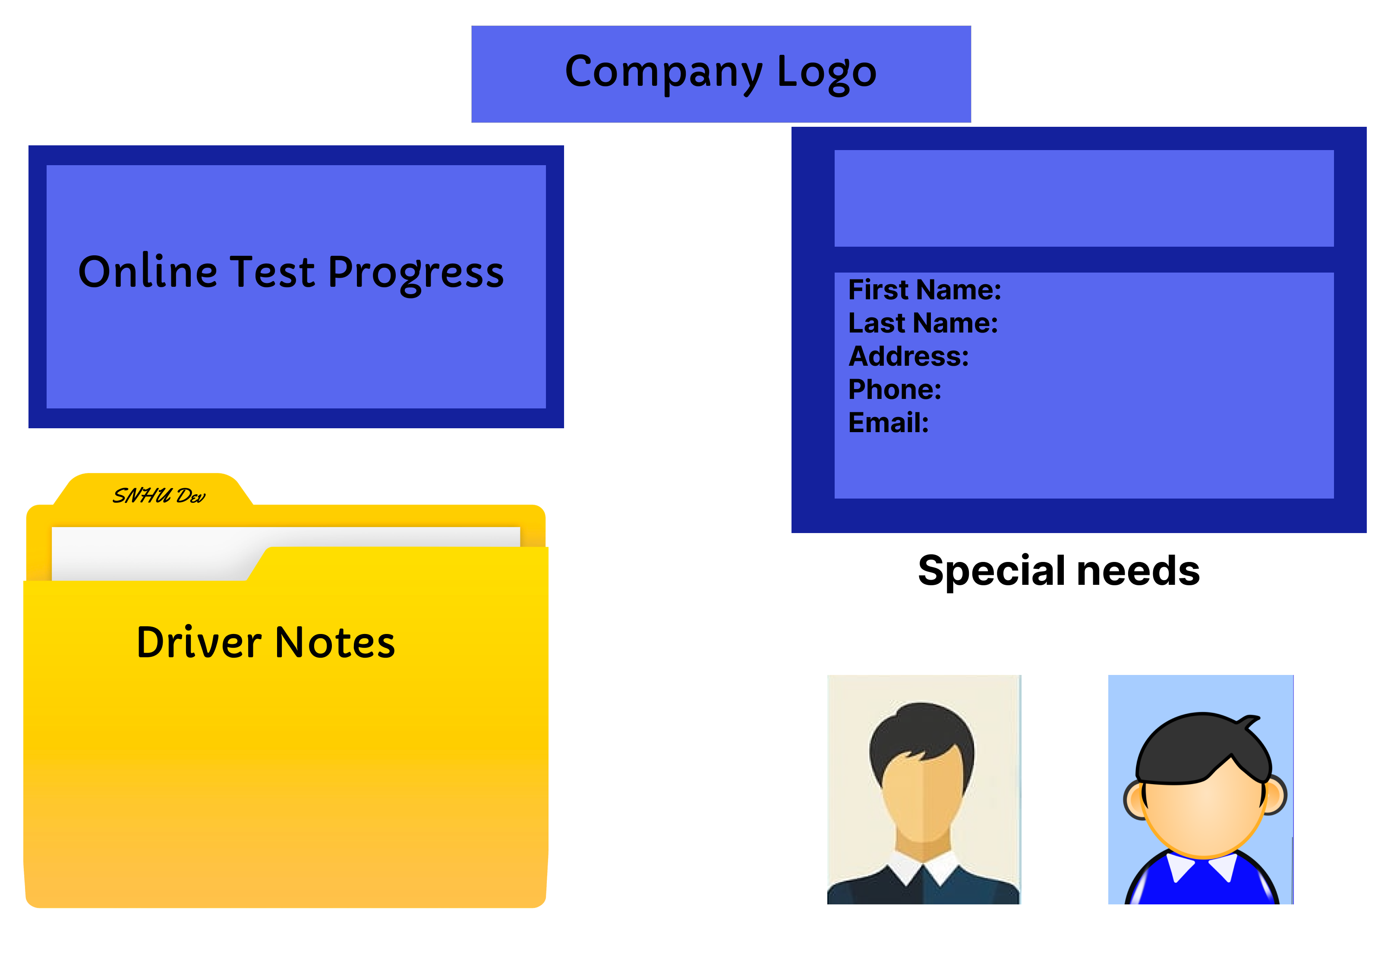

* + - * Interface
  + Cloud hosted
    - DriverPass wants to contract out backup and security
      * IaaS/PaaS/SaaS
  + Links to other pages
    - Driver Notes
    - Contact us
    - Contact Student

## Requirements

### Nonfunctional Requirements

* The system shall utilize DigitalOceans basic package and be limited to 90,000 GB - second
  + The IT technician or Super User can modify the Digital service plan and increase services as needed to expand traffic handling, storage requirements, and added functionality
* The system shall conform to all local and state regulatory requirements

#### Performance Requirements

* The system shall be web-based
* The system shall be mobile device accessible
* The system shall update it’s appointment calendar every time a user books an appointment.
* The system shall update data from the DMV weekly

#### Platform Constraints

* The system shall be cloud hosted by DigitalOcean and accessible by all Operating systems.
* The system shall rely on DigitalOcean to store it’s data
* The system shall use a scrubber to pull pertinent data from applicable government sites.

#### Accuracy and Precision

* The system shall utilize two factor authentication and available device tools such as biometrics or common access card
* The system shall ignore case for user validation

#### Adaptability

* The system shall allow the Super user and the IT technician to add/remove/ or modify user information to include password reset for all users.
* Platform updates will be properly patched in and can be rolled back by the IT technician if there is a problem
* The IT technician shall have access to add/remove/modify users
* The IT technician needs a user validation from another employee to make any changes to the Super user account

#### Security

* The system requires a 12 character alpha numeric login created by the user
* The system verifies a valid new user with captcha at the time of user creation
* The system relies on DigitalOcean to create, manage, and renew SSL certificates
* The system relies on DigitalOcean to automatically patch OS for added security

### Functional Requirements

* The system shall send notifications to the administrative assistant and instructor when an appointment is booked and verification to the customer.
* The system shall email or text appointment reminders to the customer and instructor
* The system shall lock user account after 3 failed login attempts
* The system shall verify payment completion after user books a package
* The system shall update any government regulations, rules, or laws applicable to driving on a weekly basis.

### User Interface

* The interface must allow customers to view and purchase available packages
* The interface must allow customers to modify their scheduled appointments
* The interface must allow IT technician to maintain the system
* The interface must allow administrative assistant to complete transactions and purchase packages for users calling over the phone

*- System components and design (above) further detail User roles*

### Assumptions

* DriverPass desires a static site with limited scaleability of their business model without complete redesign
* DriverPass does not contract out the driver instructor only hired employees are available to book appointments with

### Limitations

* The system will not allow a new package with different parameters to be created
* The system will not be available in multiple states. (Minor changes can be made to expand)
* The system cannot reset both the SuperUser and IT technician password

### Gantt Chart

